REDEEMER’S AIDS INITIATIVE FOR PEOPLE AND COMMUNITIES (RAPAC)

REPORT BASED ON HEALTH AND SOCIAL INTERVENTION SERVICES
BY RAPAC DURING RCCG 2024 ANNUAL CONVENTION

Reported by: Pastor Odutolu M. Olugbenga
(Acting Program Coordinator)

EXECUTIVE SUMMARY
The 72nd edition of the annual International convention with the theme “Heaven” started from Monday, August 5, to Sunday, August 11, 2024, at The Redemption City, Mowe Ogun State (Lagos-Ibadan Way) at the new ultra modern Auditorium of the Church along the Lagos/Ibadan Expressway, Nigeria.
The Redeemers Aids Initiative for People and Communities (RAPAC) in a bid to positively impact the annual convention participants with free quality Social and healthcare services. Health and counselling stands were positioned at various strategic points on the camp ground to provide health talks, medical check-ups, counselling and interactive sessions, prompt referral services to all health seeking individuals on the redemption city of God. The various tests conducted include blood sugar tests, prostrate cancer screening for men above 40 years, Malaria, HIV, Hepatitis B and C. Those identified to be positive were appropriately attended to.
In addition, there were also one-on-one medical consultations, eye care services, family planning counsels, dental check-ups and the provision of free drugs after tests for attendees. A total of 3500 were reached with quality social, health and spiritual services intervention during the convention. Our target groups during the convention include health seeking individuals, pregnant, women, men, adolescent/youths, pastors/ministers/workers, aged, barbers, deaf and dumb, hairdressers, food vendors amongst others.
In order to provide quality products and services for the annual convention participants RAPAC pre-convention activity started with sensitization/training and medical health screening checks for national kitchen staffs, Barbers, deaf and dumb and Hair dressers including food vendors who will provide services and handle/prepare/sell food during the convention. A total of 2,686 (M=679; F=2007) were medically tested. This was done in collaboration with the environmental health department.
RAPAC also focused on health/hygiene, disease prevention and control because of the upsurge in the cases of cholera in the country. This was done by creating awareness and providing the congregants as well as all departments on the camp packages containing liquid hand wash and alcohol based sanitizers. The members of staff and volunteers were engaged in distribution of behavioral change communication materials (BCC) to convention worshippers.
RAPAC collaborated with other health related units i.e National Kitchen, Camp Maternity, National Usher department, and environmental health units so as to reach more people during this year’s convention with improved social and healthcare services.
In conclusion, Spiritual information and counselling were also offered as appropriate to everyone who visited our medical stands. Some of those counselled gave their lives to Christ. It was perfect jubilee indeed as we were able to reach multitudes of congregants who expressed their gratitude for the timely intervention. The details of the various activities are highlighted in the body of this report.

A. PRE- CONVENTION ACTIVITIES
1. Conduct of food handlers test for National Kitchen Volunteers/Staffs
RAPAC conducted Tuberculosis and Hepatitis B and C screening tests for food handlers involved in selling of food for the worshippers at the 2024 International Annual Convention. A total of 1, 087 (M-357; F-730) National kitchen staff has been screened for Tuberculosis and Hepatitis.
2. Sensitization and training of food handlers, Nannies, hair dressers and Barbing salon operators:
Complete medical examination carried out of all food handlers at the time of engagement is necessary. This is due to the fact that they can be source of infection. The infections which are likely to be transmitted by the food handlers are diarrhoeas, dysenteries, typhoid and para-typhoid fevers, enteroviruses, viral hepatitis, protozoal cyst, eggs of helminths, strepto and staphylococcal infections, and salmonellosis. This was done in collaboration wity environmental health department.
3. Preparation and distribution of Hand wash and Hand sanitizers to be used at the Annual August Convention.
4. Inter-departmental taskforce against cholera at the Redemption city: RAPAC in partnership with environmental health and sanitation departments were tasked with the mandate of prevention, surveillance, detection and response against cholera outbreak because of the huge population of worshippers that will attend this year’s international annual convention.
- CONVENTION PROGRAMME ACTIVITIES
The following are the services that were carried out by RAPAC at the 2024 International Annual Convention of the Redeemed Christian Church of God (RCCG):
- STRATEGIC HEALTH SERVICES/INFORMATION POINTS
RAPAC established health services points at strategic locations for easy access so people can be reached with lifesaving social and health interventions services. Health checks, screening tests and specialized counselling were provided by our team of health care professionals and volunteers.
Health service points identified for the programme include the following:
• Back of old auditorium opposite FCMB
• Children and teens auditorium
• Redemption City Maternity and Arena clinic
• RAPAC office
• RECTEM compound
- MAINTAIN HYGIENE, DISEASE PREVENTION AND CONTROL
RAPAC team visited units and departments at the Redemption City to sensitize and create more awareness on the need for hand wash points, hygiene and health safety in preparation for the 2024 annual convention participants. RAPAC also provided and equipped them with alcohol based hand sanitizers and hand-wash liquid soap.
- . COLLABORATION WITH CAMP MATERNITY TO REACH ALL PREGNANT WOMEN
In our quest to ensure improved maternal and child health during this year’s 2024 annual convention, RAPAC staff and volunteers were stationed at the Redemption city of God maternity to reach all pregnant women in attendance with the following: Blood sugar test, HIV, Blood pressure measurement, Hepatitis and malaria test. Prevention of mother to child transmission information/services and support were also be provided. A total of 1,270 (M=1,218; F=52) people were tested and given their results.
- PROVISION OF QUALITY BASIC MEDICAL SCREENING TEST
The following health services were carried out at the 2024 annual convention to improve the health status of the participants.

• Blood Pressure
• Body mass Index
- Blood Sugar
• Hepatitis B.
• Hepatitis C.
• Prostate cancer screening
• Breast and Cervical cancer screening
• Health information/Counselling
✓ HIV Testing Services.
✓ Health education/Counselling
✓ Spiritual counselling.
✓ Sexual Reproductive health information
• Social issues counselling marriage, parent-child communication, domestic violence etc
• Referral for treatment and support.
• Linkages for services/treatment not available on the camp ground
9. PROVISION OF HEPATITIS VACCINES
RAPAC provided Hepatitis Vaccines for participants who are eligible but cannot be reached in their various parishes or localities during the national vaccine immunization program. A total of 7 (M-2; F-5) people were vaccinated against hepatitis at the programme.
10. PROVISION OF EYE GLASSES (Reading Glasses) AND DRUGS FOR THE VISUALLY IMPAIRED.
Eye care services geared towards addressing eye-related problems among the worshippers in order to improve the health the participants. A total of 793 (M-202; F-591) people were supported for eye care services with eye drops, glasses and drugs. RAPAC is making good eye care services free and readily available to all worshippers at the convention who needed these services.
11. DENTAL CARE FOR THE SPECIAL HOLY GHOST SERVICE PARTICIPANTS
During the convention, dental care services were also provided for members/worshippers who urgently needed them. Health talks on the issues surrounding oral health and the importance of maintaining standard oral hygiene practice. The goal was to empower the worshippers with adequate knowledge and tools to secure good oral health. A total of 558 (M-172; F-368) people benefitted from these oral care services.
12. HEALTH EDUCATION/ TALKS
The following health talks provided during the information sessions to the convention participant that visited our stand:
TOPICS:
▪ Health, Wellbeing & Prevention of Cholera
▪ Mental Health
▪ Diabetes & Blood Pressure
▪ HIV and Hepatitis
▪ Food safety
▪ Family Planning
▪ Social/family issues
▪ Nutrition
▪ Gender based violence
▪ Malaria Prevention for both adults and children
▪ PMTCT & Breastfeeding
▪ Health information/Counselling
▪ HIV Testing Services.
▪ Health education/Counselling
- Spiritual counselling.
- Sexual Reproductive health information
- Social issues counselling marriage, parent-child communication, Rape, domestic violence etc.
▪ Referral for treatment and support.
▪ Linkages for services/treatment not available at the Redemption city of God

13. CROWD CONTROL MEASURES
RAPAC instituted crowd control measures in order to control the crowd that throng our medical stands. The crowd control plan was executed with the assistance of a security team. The crowd control plan was well planned and executed during the annual convention.
14. COUNSELING SESSION AND SOUL WINNING
Specialized counselling were provided for those going through emotional trauma, stress and pains.
Among those given specialized counselling were four couples going through marital challenges. The cases handled include the following:
1) Financial crisis.
2) Non-payment of dowry and lack of financial support for kids.
3) Uncooperative husband who locked up his wife’s shop thereby not allowing her to do her business.
4) A woman with 3 kids ended up going for family planning but her husband got angry that he wanted more children from her despite not taking care of the kids.
There were two individual cases handled. A young girl who opted to go for mass communication but her parents wanted her to go for accountancy. This career crisis was handled by our team of experience counsellors. The second case had to do with a young man already in the university studying pharmacy but was unfortunately dropped to animal husbandry. He was counselled appropriately with his mum and developed an action plan on the next step to take.
A total of 42 (M-17; F-25) people were led to Christ during the various counseling sessions.
15. PROVISION OF HEALTH CARE SERVICES FOR PEOPLE WITH DISABILITY
This year’s convention marked the provision of medical screening to the deaf and dumb who came for the convention. Those tested among them came from different units of the Redeemed Christian Church of God such as the National Kitchen, Sanitation, ushering and general population. A total of 34 persons with disability were attended to.
16. REFERRAL SERVICES
Referral in the health system is a systematic process for the optimal allocation of resources and improves the access of people in need of treatment services. The clients in need of further care and support will be referred for the services that are not available at the Redemption city of God.
At this year’s annual convention, the congregants discovered to have tested positive to HIV were 8 in total. Two females were referred to health facilities close to them for further care and treatment. The remaining six were enrolled under RAPAC treatment platform. Also, a total of 43 (M=12; F=31) people tested positive to Hepatitis B. They were referred to the appropriate treatment sites closest to them.

DATA PAGES

TOTAL SCREENING DONE DURING RCCG 2024 ANNUAL CONVENTION
 | MALE | FEMALE | TOTAL
HEPATITIS B | 577 | 1976 | 2553
HEPATITIS C | 232 | 839 | 1071
MALARIA PARASITE | 679 | 2007 | 2686
BLOOD SUGAR LEVEL | 438 | 1274 | 1712
HIV | 586 | 2085 | 2671
POSITIVE CASES IDENTIFIED
 | MALE | FEMALE | TOTAL
HEPATITIS B | 12 | 31 | 43
HEPATITIS C | 2 | 0 | 2
MALARIA PARASITE | 80 | 183 | 263
BLOOD SUGAR LEVEL | 46 | 152 | 198
HIV | 0 | 18 | 18
 | NORMAL BP |  | SUBOPTIMAL BP
 | MALE | FEMALE | MALE | FEMALE | TOTAL
BLOOD PRESSURE | 197 | 507 | 65 | 149 | 918
PROSTRATE CANCER SCREENING (MEN ONLY) | 398
DRUGS DISPENSED | 423
EYE CHECK | 793
 |  |  | REFERAL
 | MALE | FEMALE | MALE | FEMALE | TOTAL
DENTAL | 172 | 386 |  |  | 558
 |  |  | REFERAL
 | MALE | FEMALE | MALE | FEMALE | TOTAL
EYE CHECK | 202 | 591 |  |  | 793

PICTURE GALLERY
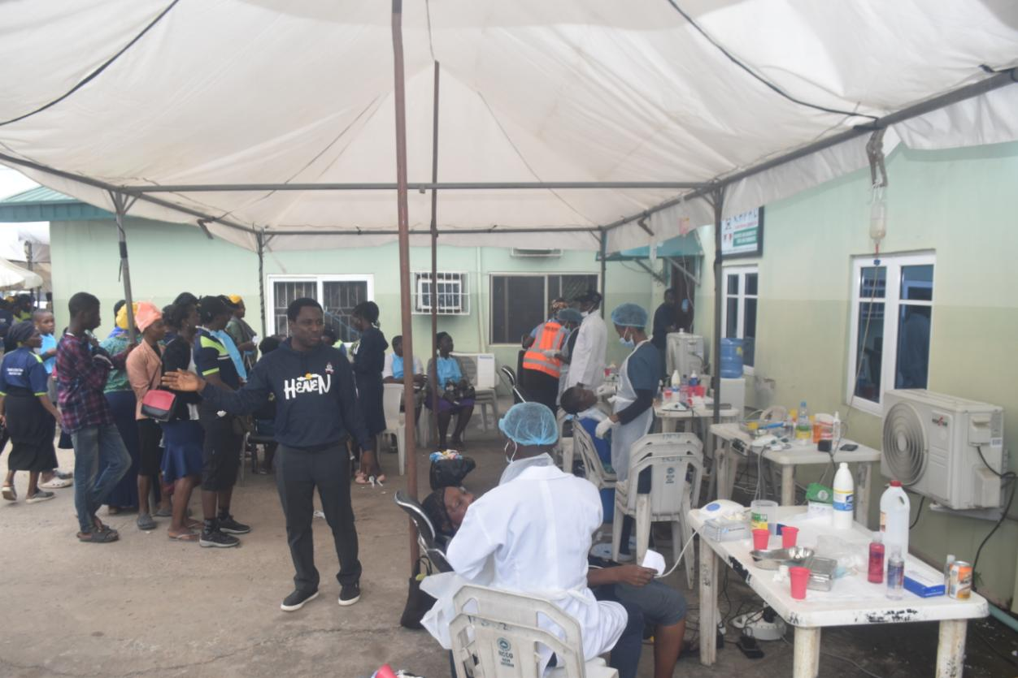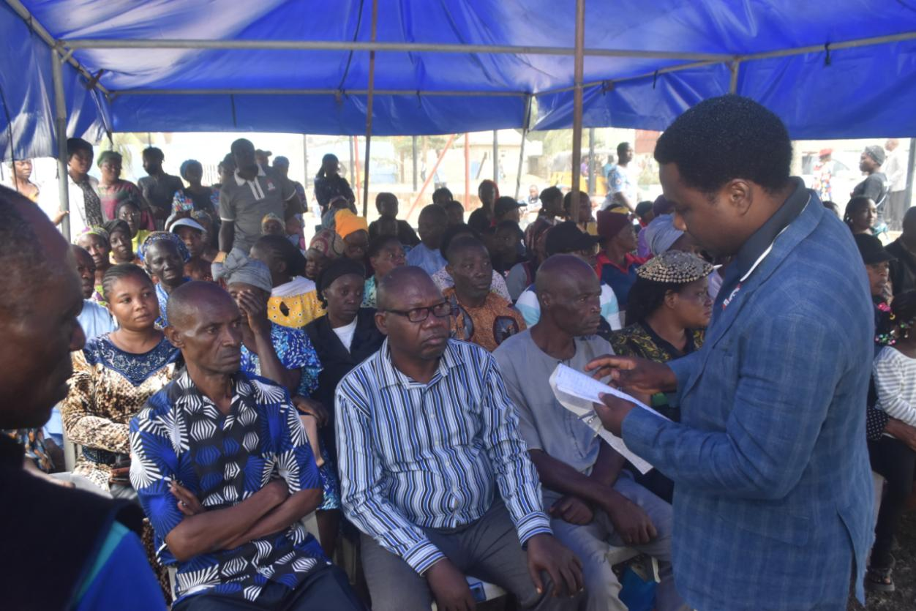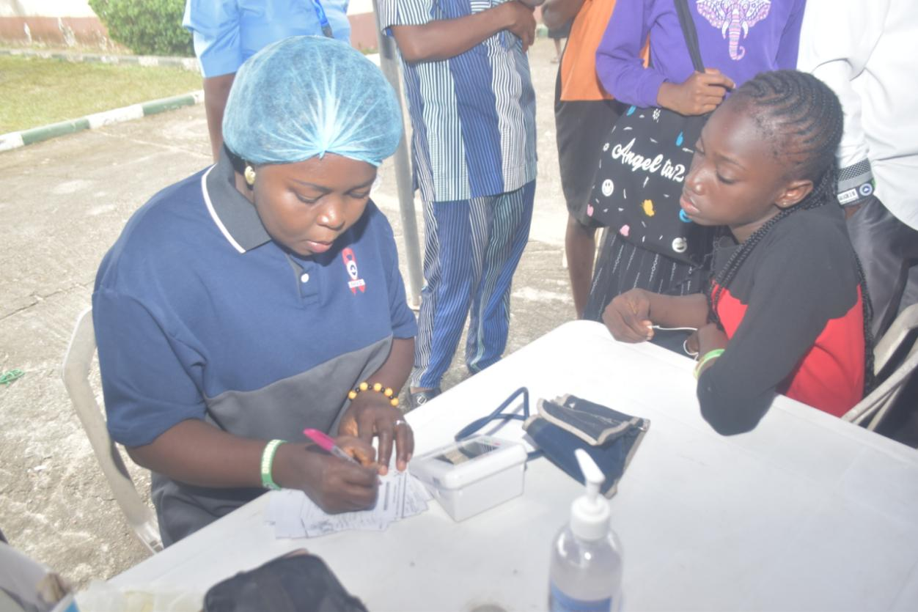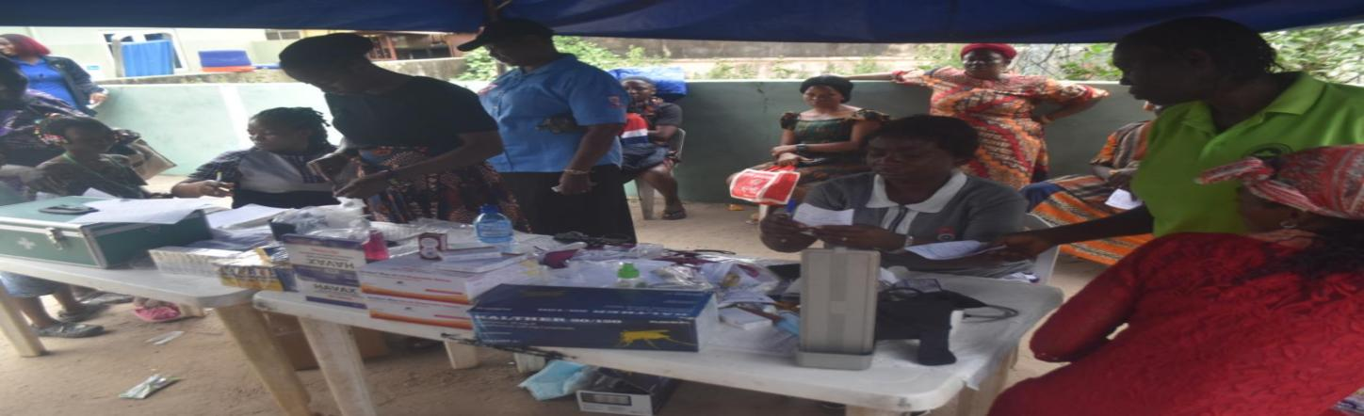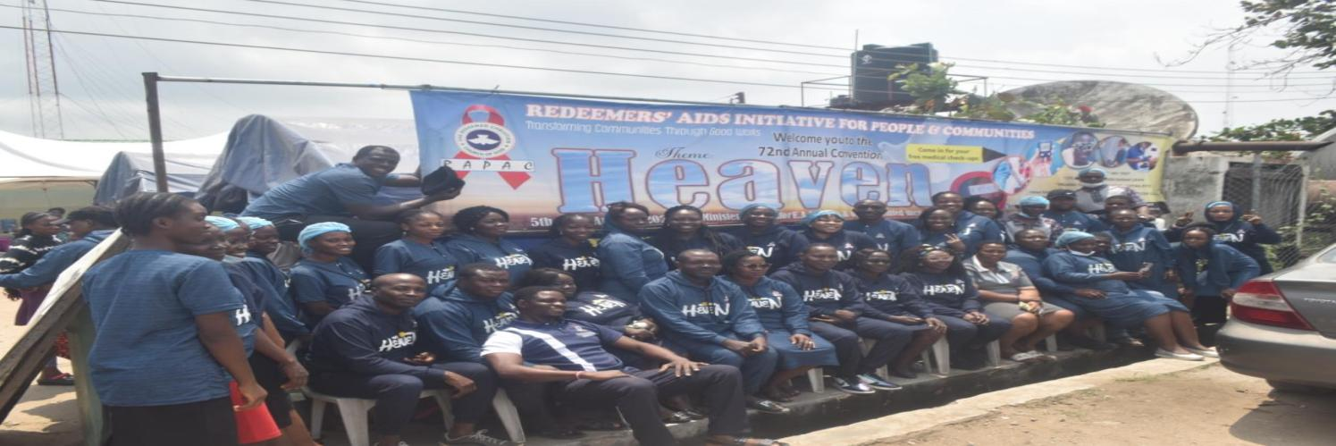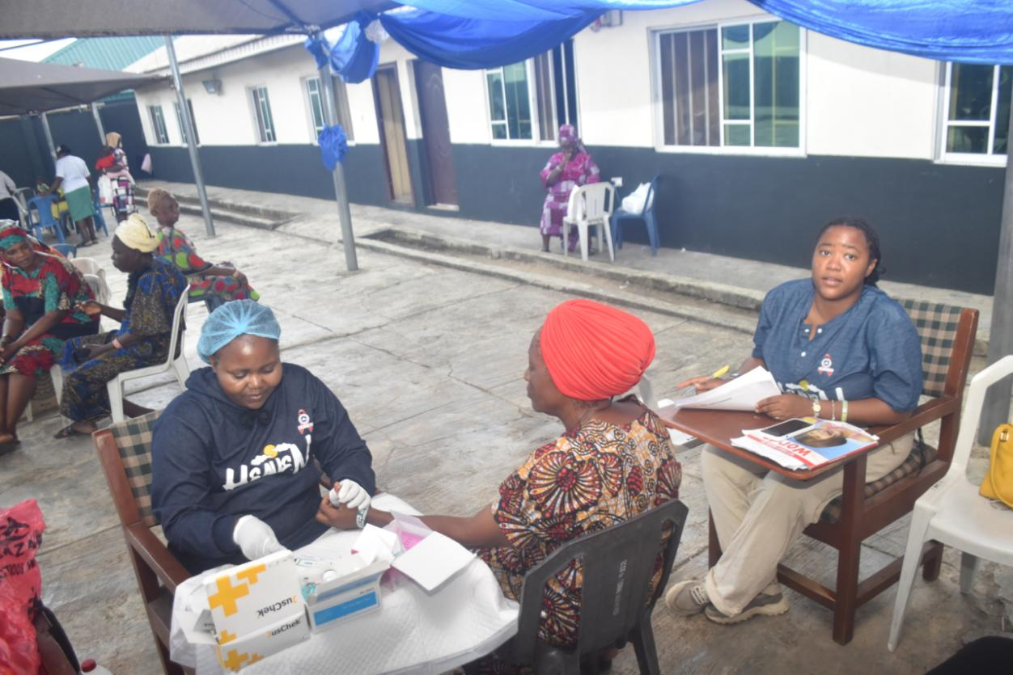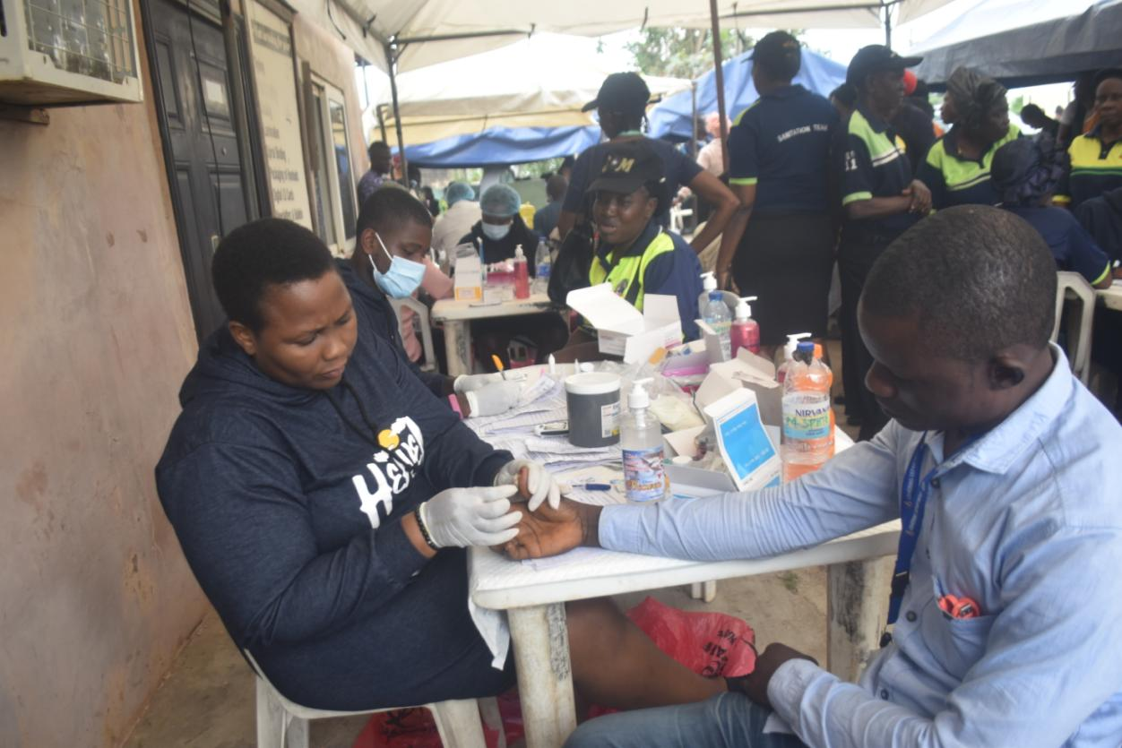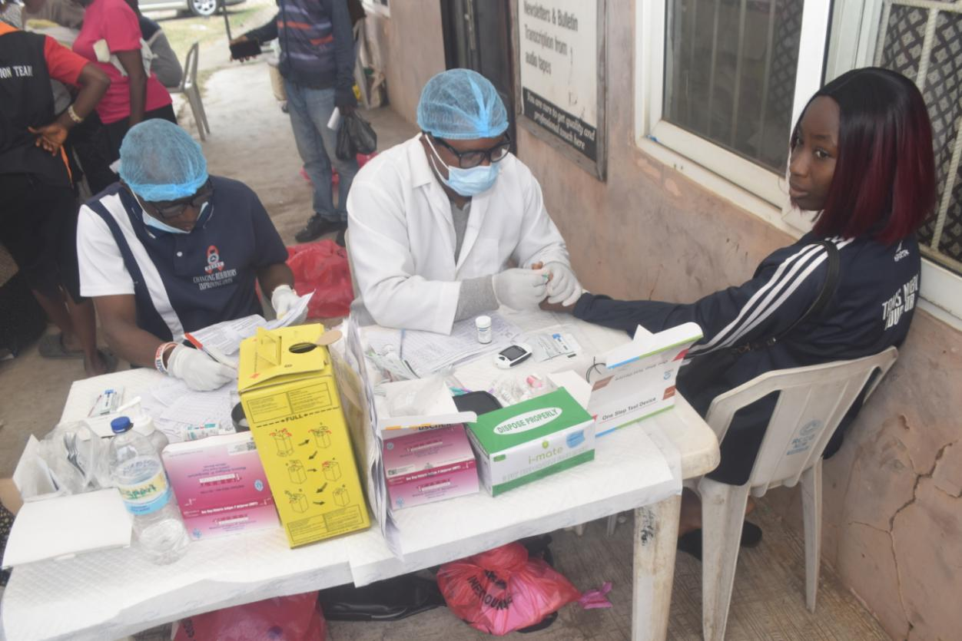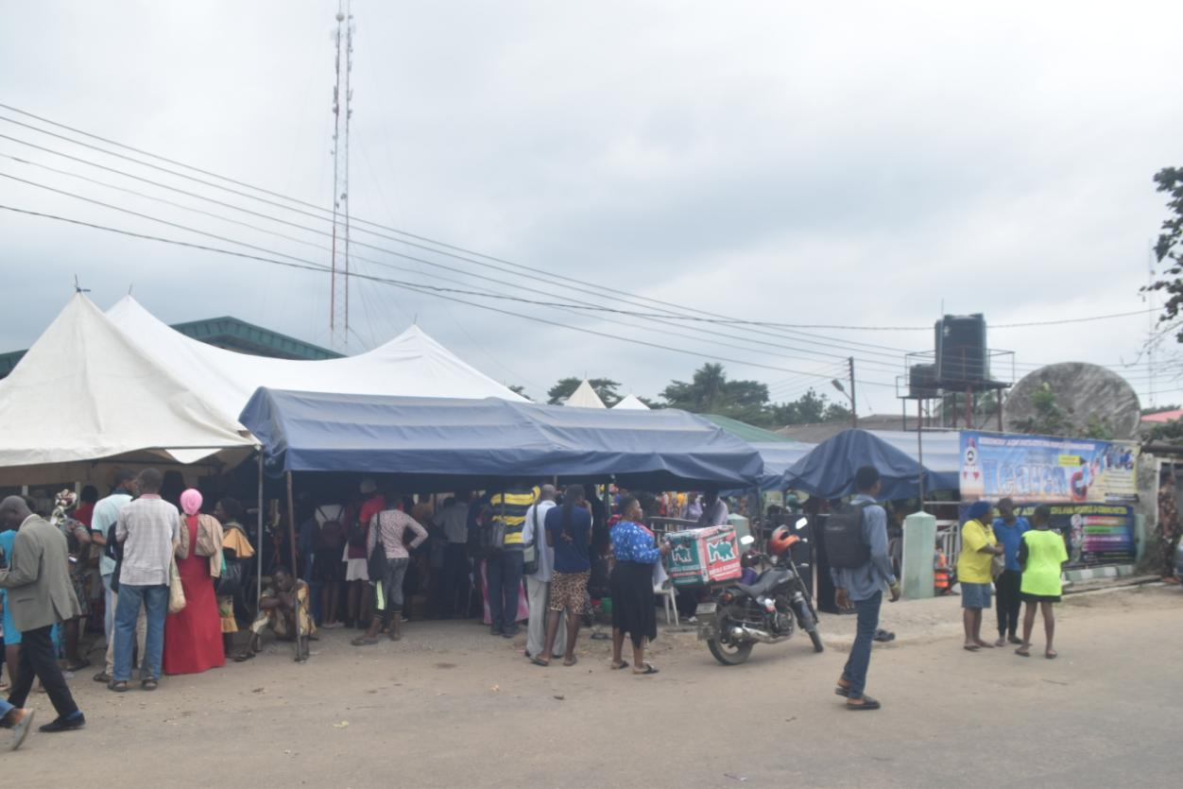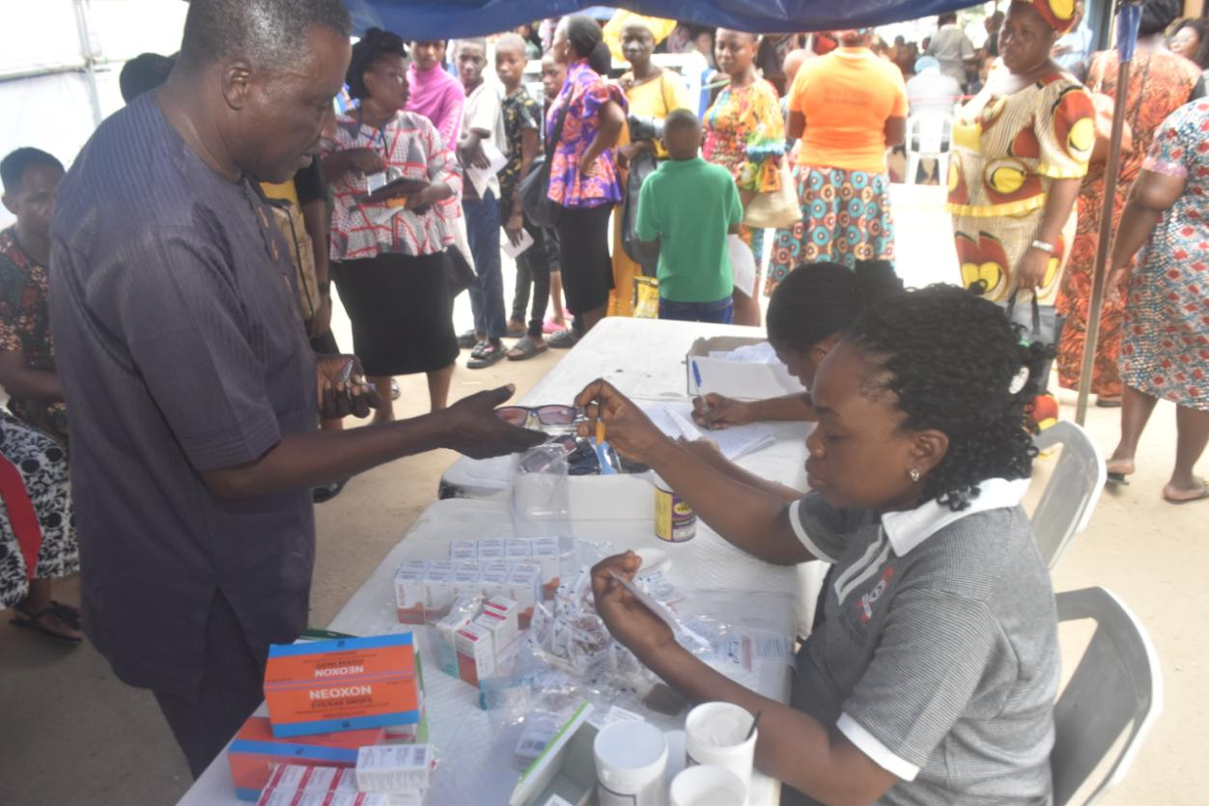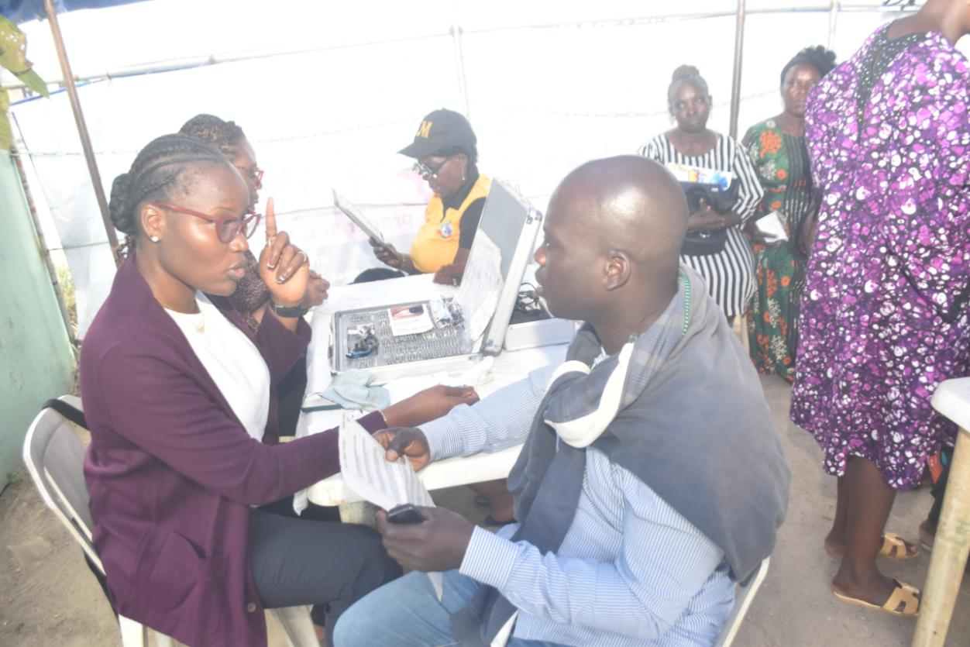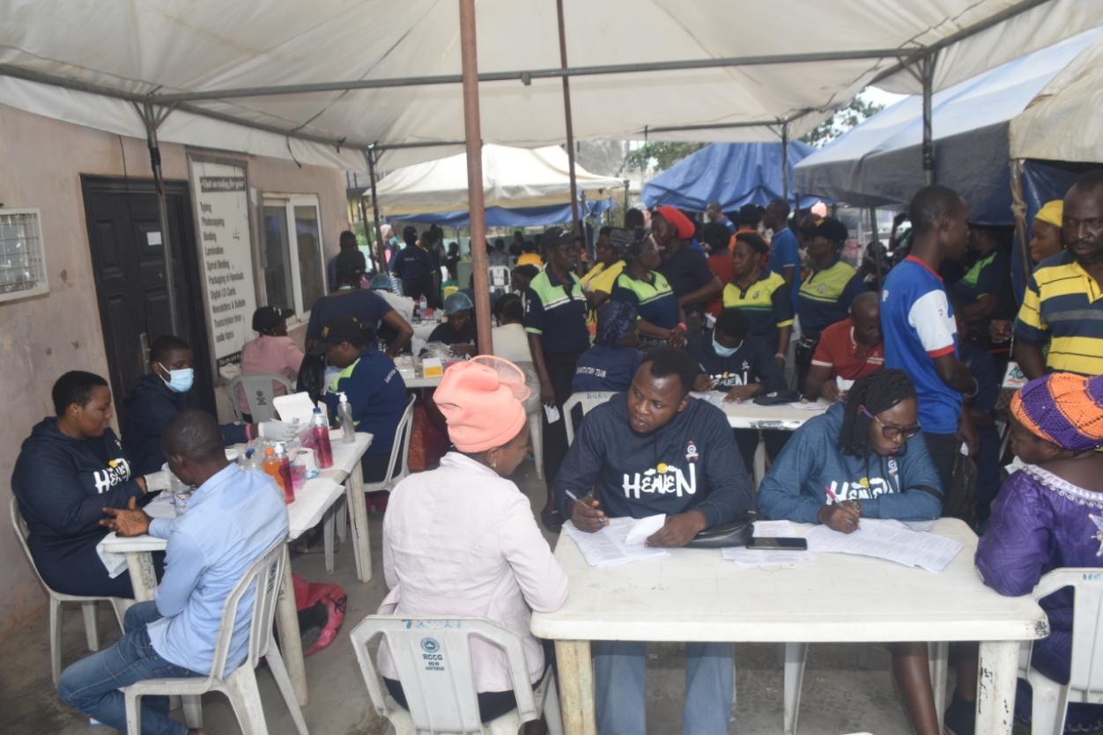

- RECOMMENDATION AND CONCLUSION
We blessed God for the huge success recorded in this year’s convention as we were able to reach over 2,898 (M-794; F-2,104) convention participants with social and health intervention services. All the units and departments also cooperated to ensure disease prevention and control, RAPAC will continue in this God’s giving mission if Jesus tarries.
We want to report a worrying trend on the high increase in the number of people who tested positive to hepatitis B i.e 43, Malaria- 263 and HIV – 18. Hence the need to RAPAC create more awareness on Hepatitis, HIV and Malaria in the church such that members and ministers can take charge of their health.
As part of our faith based response, RAPAC will continue to follow up and track those whose health challenges were identified to ensure continuum of services.
- CHALLENGES
At our planning session for the convention, we planned to reach more people who needed social and health services but we were hampered by shortage of funds. We hope this challenge will be addressed before the Holy Ghost congress in December as we hope to do more.
In conclusion, we give glory to God for the tremendous success achieved by our department at the annual international convention which was possible with the support of the mission and other collaborative effort. RAPAC will continue to reach the church and host communities’ with life-saving services to support the mission’s effort to win as many souls as possible for Christ.
We pray that God will meet the needs of the church so that we can experience heaven on earth by granting us improved living standard and good health.

